Cognifyz IT Solutions pvt.ltd
Task: Restaurant Recommendation System
HARINI R
Ref.: CTI/A1/C34761

Aim:
To give the recommendation of the restaurant for the users giving input features like cuisines, aggregate required rating and the price range
Dataset Description
The dataset contains multiple features related to restaurants
Restaurant Information
- Restaurant ID
- Restaurant Name
- Country Code
- City
- Address
- Locality
- Locality Verbose
Location Features
- Longitude
- Latitude
Service Features
- Cuisines
- Has Table booking
- Has Online delivery
- Is delivering now
- Switch to order menu
Pricing Features
- Average Cost for two
- Currency
- Price range
Target and Feedback Features
- Aggregate rating (Target variable)
- Rating color
- Rating text
- Votes
System Architecture
1. Front-End Features
- Built using HTML and CSS
- Provides an interactive UI where users can:
  - Enter cuisine preference
  - Select price range
  - Set minimum rating
- Displays recommended restaurants in a structured format (cards/table)
2. Back-End Features
- Developed using Flask (Python Web Framework)
- Handles:
  - User input processing
  - Data filtering and recommendation logic
  - Communication between UI and dataset
3. API Integration
- Integrated Foodish API
- Generates random food images based on cuisine type
- Enhances visual appeal of recommendations

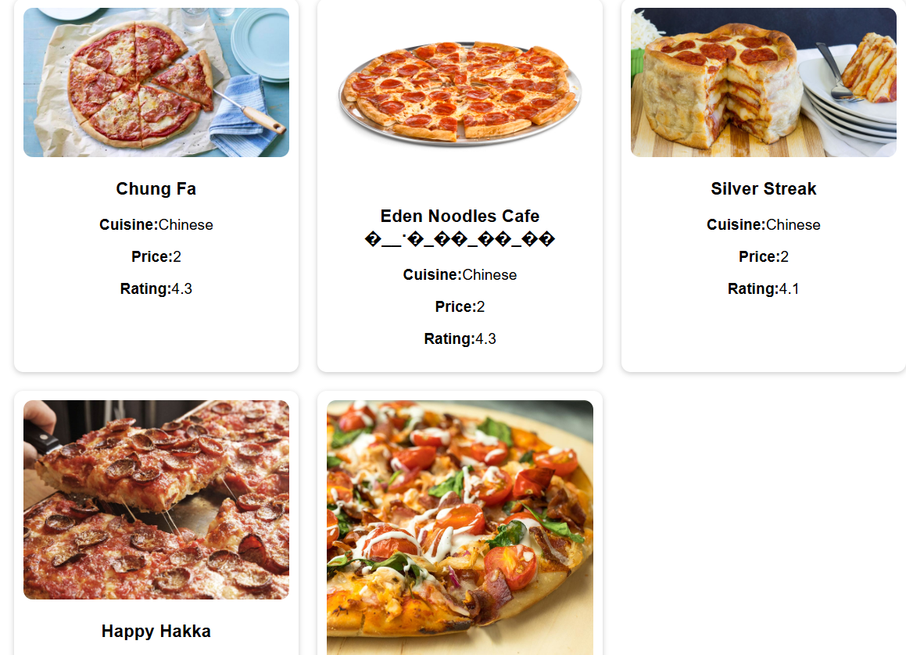

Programming Features
Libraries Used
- Pandas → Data manipulation and preprocessing
- NumPy → Numerical computations
- Flask → Web application framework
- render_template → Loads HTML pages
- request → Captures user inputs
- requests → API integration for images
- random → Random selection of food images
- MultiLabelBinarizer → Converts categorical cuisines into numerical format
- cosine_similarity → Measures similarity between user preferences and restaurants

Data Preprocessing Techniques
- Handling Missing Values
  - Missing cuisines replaced with "Unknown"
- Cuisine Transformation
  - Converted cuisines into list format
  - Example:"Indian, Chinese" → ["Indian", "Chinese"]
- Removing Duplicates
  - Ensures unique restaurant entries
- Feature Encoding
  - Used MultiLabelBinarizer to convert cuisines into binary vectors
  - Example:
    - Indian → 1
    - Chinese → 1
    - Italian → 0
- Feature Combination
  - Combined:
    - Cuisine encoding
    - Price range
  - To create a unified feature set
Recommendation System
Working Process
- User Input
  - Cuisine
  - Price Range
  - Minimum Rating
- Feature Encoding
  - User input converted into numerical vector
- Similarity Calculation
  - Uses cosine similarity to compare:
    - User vector
    - Restaurant dataset
- Filtering
  - Filters restaurants based on:
    - Matching cuisine
    - Rating ≥ user input
- Ranking
  - Sorts restaurants by:
    - Similarity score
    - Aggregate rating
- Top Recommendations
  - Returns top N restaurants
Image Generation Logic
- Based on cuisine type, system maps to food category:
  - Indian → Biryani / Dosa / Idly
  - Italian → Pasta
  - Chinese → Noodles
  - American → Burger
- Fetches random image using Foodish API

Limitations
Limitations
- Dataset Bias
  - More Indian restaurants → may dominate recommendations
- Limited Cuisine Coverage
  - Some cuisines like American/Japanese have fewer entries
- Image Accuracy
  - Foodish API supports limited categories
  - Some images may not perfectly match cuisine
- Single Cuisine Input
  - System currently supports only one cuisine at a time
- No User Personalization
  - Does not learn from past user behavior
Deployment
Uploaded the files in github and published it in render
Render link:
https://cognifyz-1-vsnu.onrender.com/
Git hub link
https://github.com/harini-012/Cognifyz/tree/main/task2

Conclusion
The Restaurant Recommendation System successfully:
- Uses content-based filtering
- Processes real-world restaurant data
- Provides customized recommendations
- Integrates API-based food images
- Delivers an interactive user experience through Flask

